Date: March 7, 2022

From: William B. Killingsworth, Director
Planning and Development Department

To: Rules Committee

Re: Redistricting White Paper

Council Members, from January 2021 through May 2021 the prior Special Redistricting Committee (First Special Committee) met and was provided some redistricting data from its consolidated government expert. In particular, I’ve attached the maps that illustrate race by precinct and party affiliation by precinct. These are maps 15, 16, 17, and 18. The paragraphs below represent a chronologically ordered discussion of material presented and discussed at the Special Committee on Redistricting established by Council President Newby and at the Member to Member Noticed meetings that I attended from August through December, 2021.
SPECIAL COMMITTEE ON REDISTRICTING - August 18, 2021
I discussed the department’s role in the process and the restrictions of the Government in the Sunshine Law on what information I can provide to the committee members between the noticed meetings to be in compliance with the Sunshine Law. I discussed several possible considerations the committee may want to take into account in instructing the department how to proceed developing proposed districts: total population basis vs. voting age population (the City has traditionally used total population); geographic considerations (i.e. keeping all the Beaches cities in one council district; minimizing river crossings; keeping all of Cecil Field/Cecil Commerce Center in one district); downtown representation considerations (is it better to have downtown contained within one council district for maximum attention of a single council member or to divide downtown among multiple districts to broaden the number of representatives for the area); respect major boundaries (highways, rail lines, rivers, political jurisdiction lines, etc.); represent communities of interest (maintain the existing community of interest districts largely intact); political factors; protect incumbents in office.
I stated the department will need some fundamental instruction on how the committee wants to proceed – whether to work from existing district boundaries and adjust as little as possible or whether to start from scratch and use the data to draw entirely new districts.
I explained the hierarchy of Census data – census blocks (the size of a city block, with a few hundred residents) aggregate into block groups (neighborhood level with a few thousand residents), which aggregate into census tracts, which aggregate up to the county level (Jacksonville has approximately 100 census tracts). I stated that early analysis shows that using total population as the basis will produce districts with slightly higher deviations above the target on the south/east side of the river and slightly lower deviations below the target on the north/west side.
The committee voted to make the Director the consultant. It also voted to have the consultant work from the existing council districts rather than create new ones.

SPECIAL COMMITTEE ON REDISTRICTING - August 24, 2021
I stated that I used the word “criteria” at the last meeting instead of the term considerations. I did not intend to imply that the factors being considered were hard and fast requirements. I listed a number of possible considerations that could inform the process of crafting proposals: compactness; contiguity (all parts of a district must be connected); incumbency - don’t draw multiple incumbent elected officials into the same district; river crossings – minimize, prohibit, no restriction; total population basis vs. voting age (18 and older) population basis; preserve traditional communities of interest; start by refining current districts vs. start from scratch with a clean slate.
I also discussed the census numbers, potential target population sizes based on total population and voting age population, and the impacts of a district crossing the river.
The committee voted to have the consultant use total population. Additionally the committee voted to not draw sitting City Council members or School Board members out of their districts and to minimize river crossings to the extent possible.

COUNCIL MEMBER TO MEMBER NOTICED MEETING - September 2, 2021
I presented a first proposed map of the districts south and east of the St. Johns River and described how the existing districts were adjusted to get to this first proposal.
My takeaways from the meeting were to produce a new map that: 1) keeps the Regency Square area in District 1; 2) takes the Baymeadows area out of District 4 and replaces it with the Deerwood area; and 3) returns a river crossing to District 2 as it currently exists to see how that affects the other districts on the south/east side of the river.
See attachment Map 1.

COUNCIL MEMBER TO MEMBER NOTICED MEETING - September 7, 2021
I discussed the three options: the Planning Department’s initial proposal for the south/east side of the river, plus plans requested by Council Members Becton and Ferraro after discussions with staff. CM Becton’s proposal differed from that of the Planning Department by shifting the Bartram Park area (12,000 population) from District 11 to District 6, shifting the area between Baymeadows Road and Butler Boulevard from District 4 to the northwest corner of District 11, and shifting a portion of the northern end of District 4 to the westward and the southern end of District 5 further south. Council Member Ferraro’s proposal differs from that of the Planning Department by shifting the district’s eastern boundary north of Atlantic Boulevard eastward to the Intracoastal Waterway and shifting the boundary of the southeastern corner of the district westward from Kernan Boulevard.
See attachments Map 1, Map 2, and Map 3.

COUNCIL MEMBER TO MEMBER NOTICED MEETING - September 9, 2021
I reported that the members attending the two previous noticed council member meetings indicated each separately to me an interest in allowing District 2 to continue to cross the river. I described the changes to CD 7, 8, and 12.
At CM Gaffney’s suggestion, the council members proposed areas of their districts that they would be willing to see transferred to other districts to make the population deviation work.
CM DeFoor said she would be willing to give up an area north of College Street in Riverside on the north end of her district, particularly if she could gain territory in the Argyle Forest area.
CM White said he would be willing to give up an area along Otis Road in the northwest of his district provided that the Town of Baldwin is kept in one district, and could give up the Marietta area to District 8 (Jones Road, Old Plank Road, Beaver Street, I-10 area).
CM Priestly Jackson said she could agree to minor tweaks around the edges of her district as needed to make everything balance.
CM Dennis said he supports the Myrtle Avenue area being in District 8 as it has traditionally been but prefers no changes to his district.
CM Pittman said she is agreeable to the District 12 and District 7 exchanges with District 8 discussed earlier.
See attachment Map 4.

COUNCIL MEMBER TO MEMBER - September 22, 2021
I discussed the two new map proposals that resulted from the discussion at previous council member noticed meetings. The maps both have District 2 crossing the St. Johns River. The first new option places the Bartram Park area in District 6 and the Pablo Creek area adjacent to the Intracoastal Waterway south of J. Turner Butler Boulevard in District 3. The second new option places Bartram Park in District 6, keeps the Pablo Creek area in District 3, and shifts the border between Districts 3 and 4 in the Sandalwood area along Kernan Boulevard to the west.
I summarized what I heard from the participants: the consensus seems to be that today’s option 1 looks good if some population-neutral changes can be made between Districts 2 and 3. CM Bowman said he is still concerned about the loss of schools and doesn’t want District 3 to go below the 4 schools as shown now; he’s fine with the rest. CM Boylan said he is fine with option 1. CM Carrico said he is fine with option 1 and is still open to making small tweaks around the edges of his district. CM Cumber said she is fine with option 1. CM Ferraro reiterated his concern about the major losses to his district on west edge of the Northside portion.
See attachments Map 5 and Map 6

COUNCIL MEMBER TO MEMBER - September 23, 2021
I stated that the council members south/east of the river seemed to reach a consensus on a plan for those districts. I described the changes made to the maps presented today for those south/east districts. This meeting centered on the interactions between CD 7, 8, and 12. Various options were explored.
See attachments Map 7, Map 8, and Map 9.

SPECIAL COMMITTEE ON REDISTRICTING -September 27, 2021
I stated that I will be meeting individually with Council Members from districts 7, 8, and 12 later this week to discuss the District 2/7 boundary and also the District 8/12 boundary.
See attachment Map 10.

COUNCIL MEMBER TO MEMBER - OCTOBER 21, 2021
I described two maps prepared for the meeting. Districts 9 and 10 have not changed in these proposals, I have spoken with all of the other affected council members individually about these proposals and gotten their reactions. I said that adjustments have been made to the boundaries between Districts 2 and 7, 7 and 8, and 12 and 14.
CM Pittman said she had a noticed member-to-member meeting with CM White last week and is satisfied with the boundaries that have been proposed today. CM Ferraro said he had met with Mr. Killingsworth once and still has some questions about adjustments made on the southern end of his district and will be meeting with Mr. Killingsworth again. CM DeFoor said that the north boundary of her district in Riverside will remain the same and she is adding a bit of the Argyle area on the southwest end of the district from District 12 to help get more of Argyle into a single council district. I stated that I talked to Council Member White just before the meeting who told me that he is comfortable with the District 12/14 boundary adjustment.
See attachments Map 11 and Map 12

SPECIAL COMMITTEE ON REDISTRICTING - October 28, 2022
I stated the districts south/east side of the river are basically unchanged since the last noticed meeting of the south/east council members, except for a slight adjustment to the border of districts 3 and 4 along J. Turner Butler Boulevard at Gate Parkway. CM Carrico (District 4) said he agreed to the change and I said CM Bowman (District 3), who was excused from today’s meeting, had been informed and agreed to that change. On the north/west side of the river, I described changes to the districts 7 and 8 border (between Lem Turner Road and New Kings Road), the districts 7 and 2 border (in the North Main Street and Yellow Bluff Road area and the Imeson Park area between Eastport Road and Zoo Parkway), and the districts 12 and 14 border (in the Collins Road and Shindler Drive area of Argyle Forest).
I presented the at-large map, explaining that the current proposal mostly mirrors the existing boundaries with some changes to make the populations balance. Residence Area 5 needed to grow to meet the required population deviation so a portion of the Riverside neighborhood was shifted from Residence Area 4 in order to keep all of Riverside in one at-large area, and additional territory was shifted from Residence Area 1 in the Zoo Parkway/Imeson Park/Eastport area to make up the needed population. The committee voted to move the presented Proposed Council District Map and the Proposed At-Large Map to the Rules Committee.
See attachments Map 13 and Map 14.

OTHER DATA
The Table 1 illustrates party affiliation by council district for the current and proposed maps. Table 2 shows the population and race profile for the existing districts and the proposed districts.
Data and maps prepared by the consolidated government expert during the First Special Committee are included as part of the record and can be found on the City Council webpage under Hot Topics.

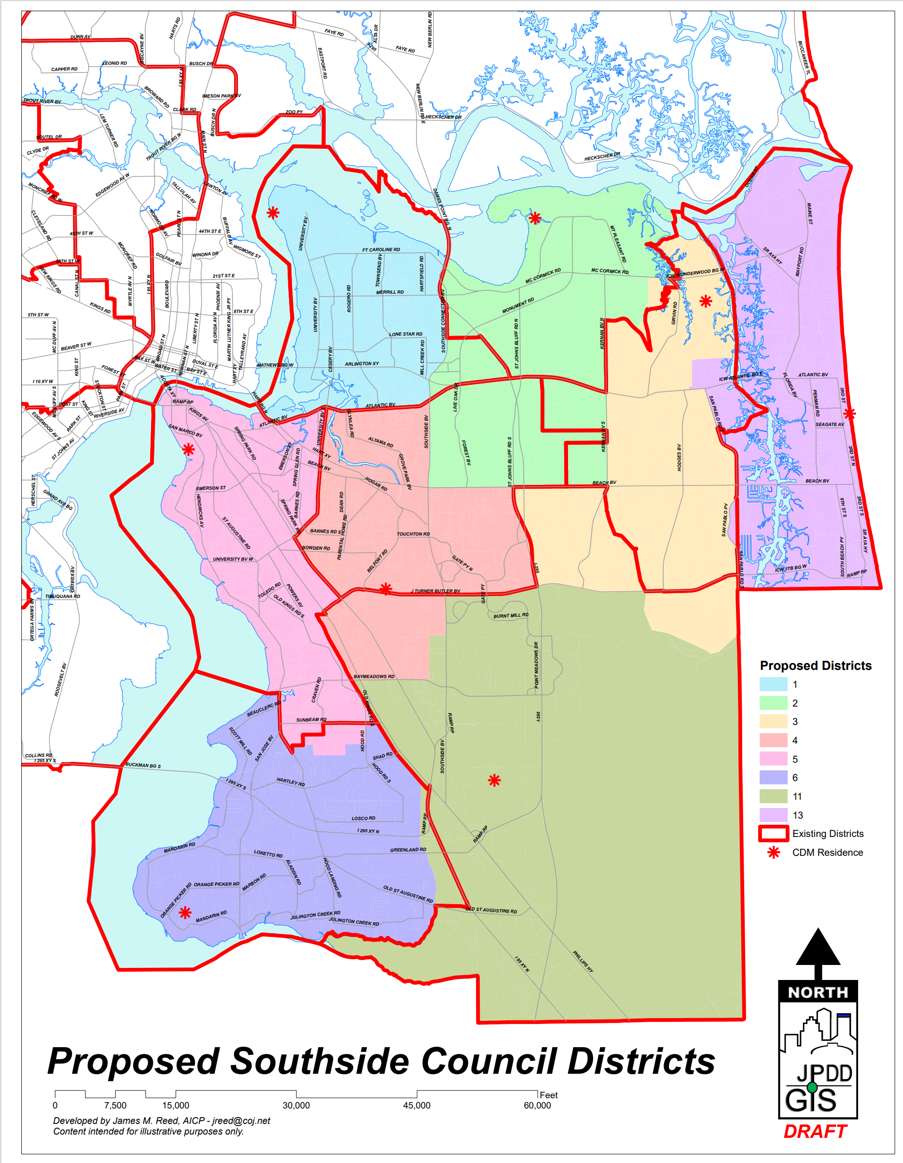
Map 1
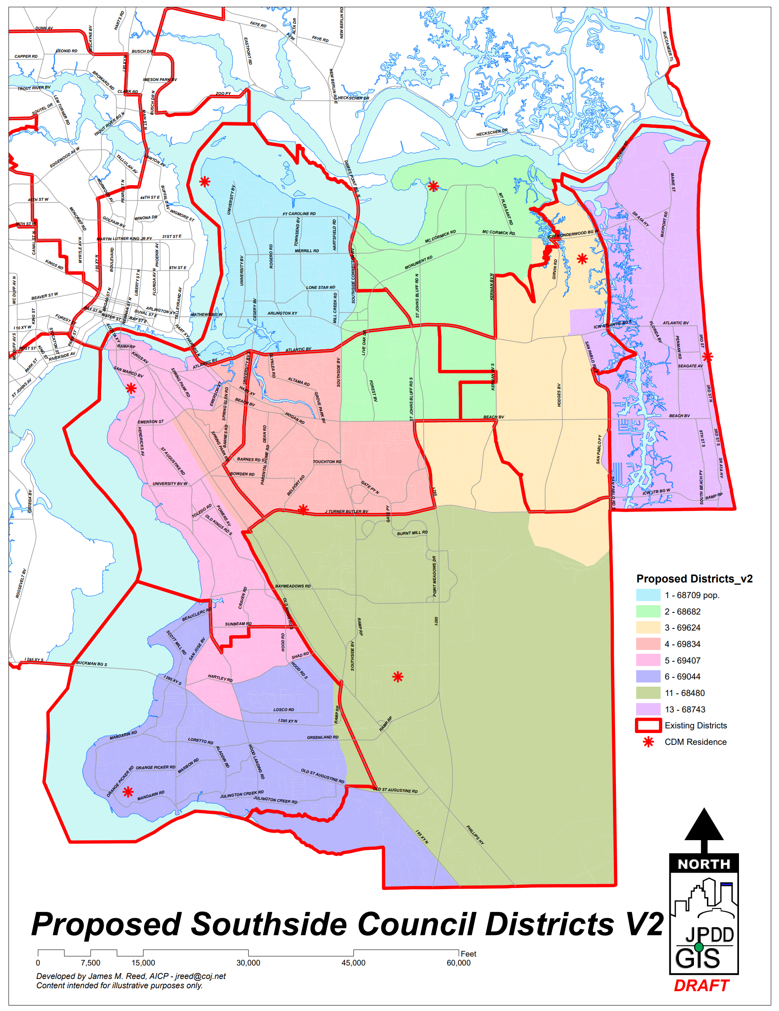
Map 2
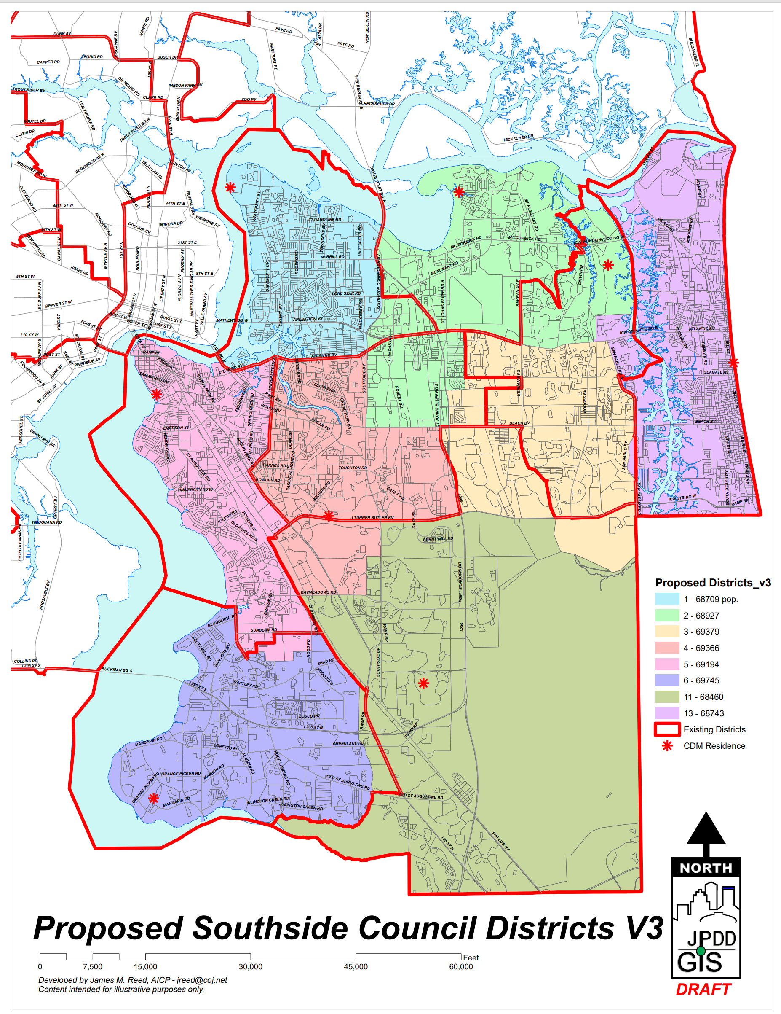
Map 3
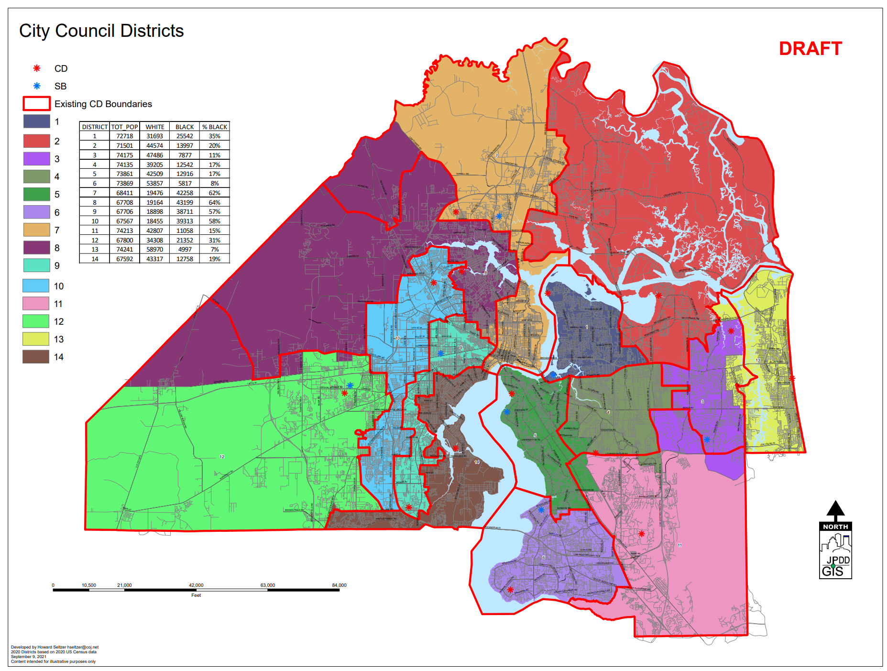
Map 4
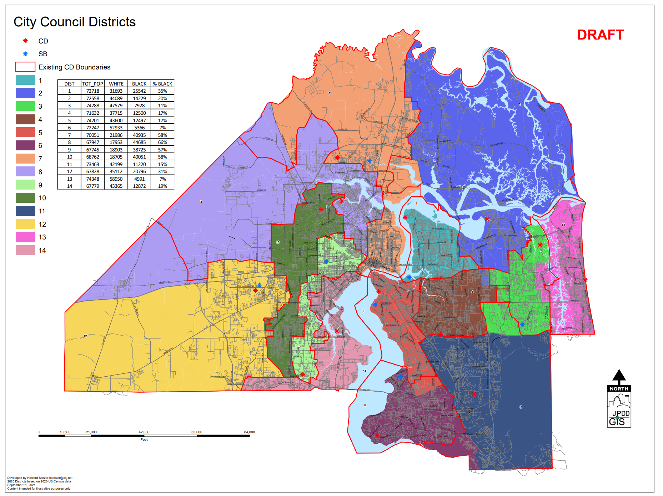
Map 5
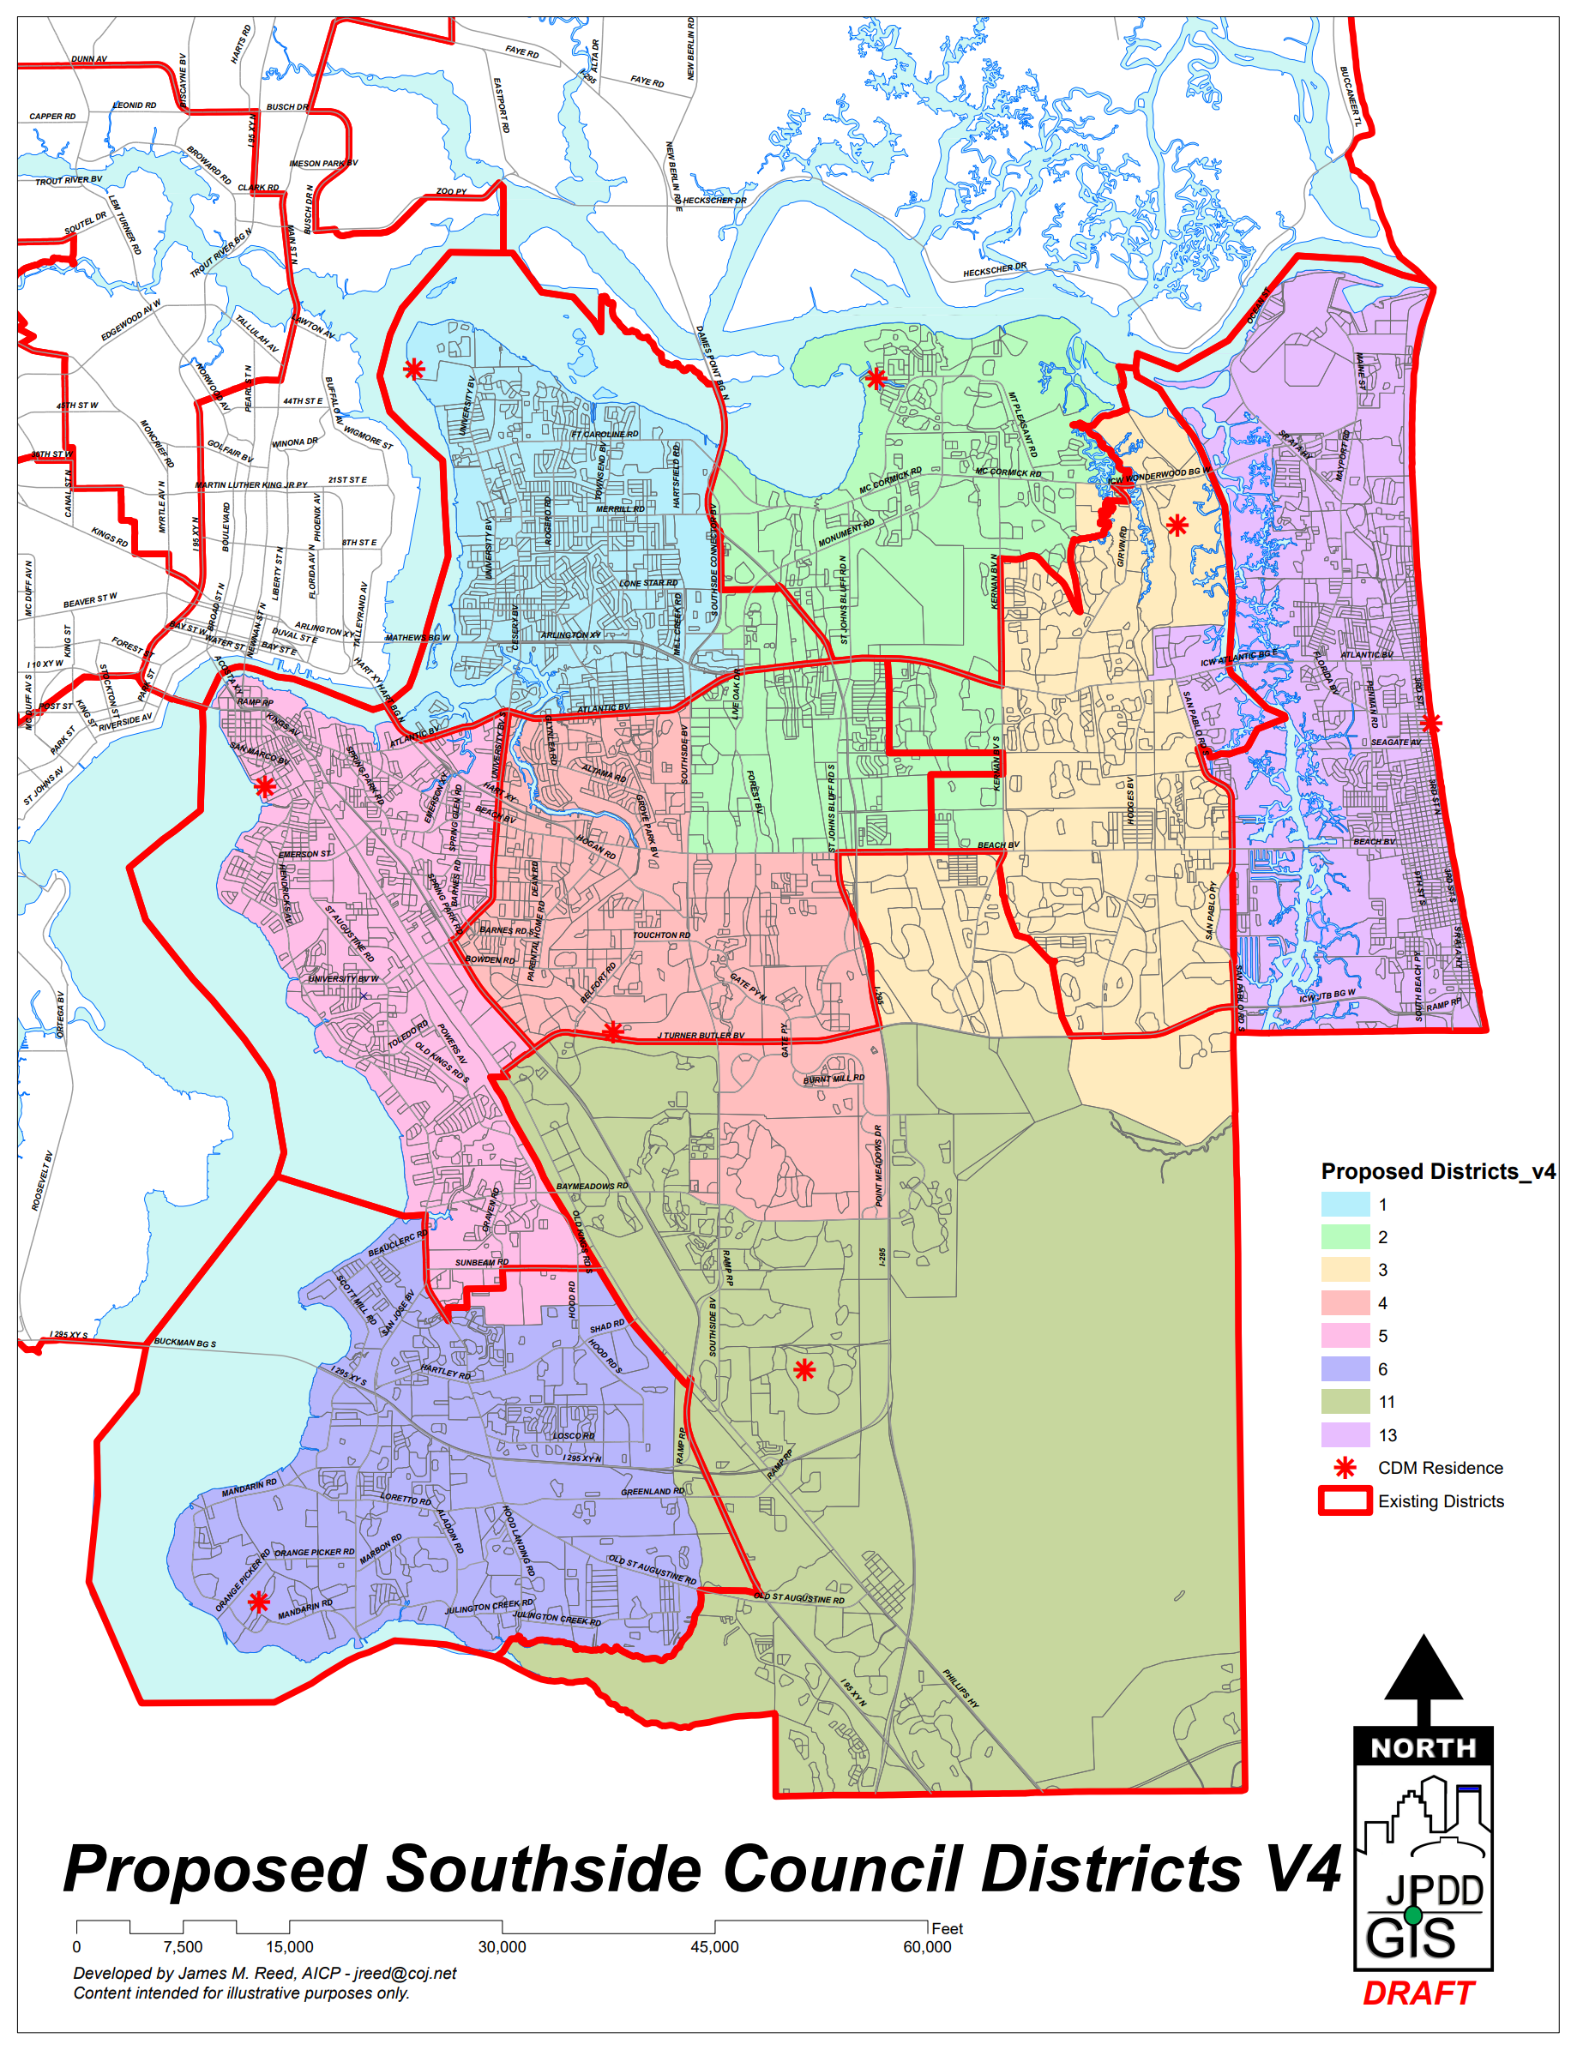
Map 6
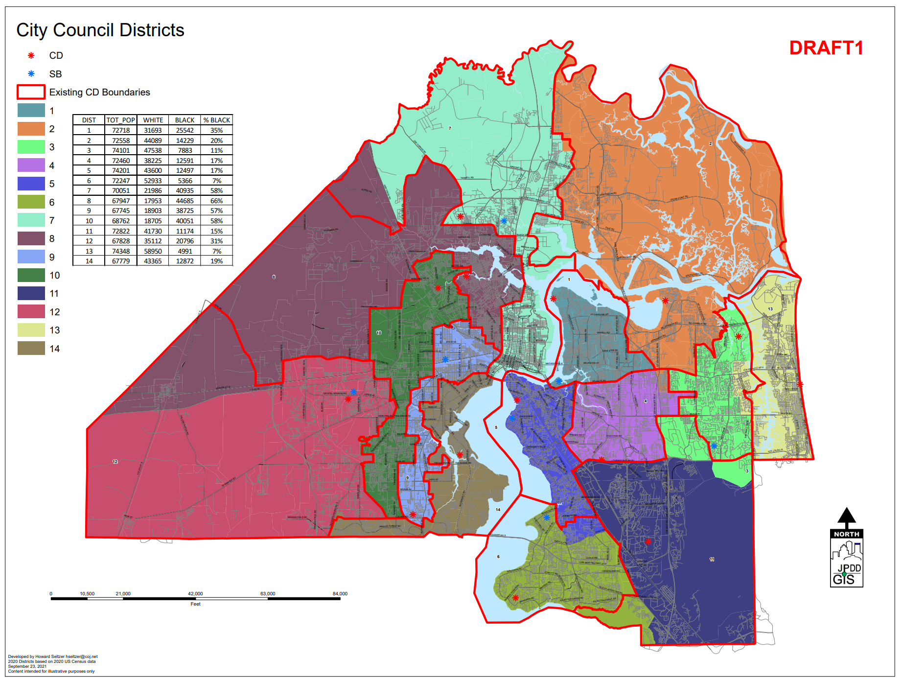
Map 7
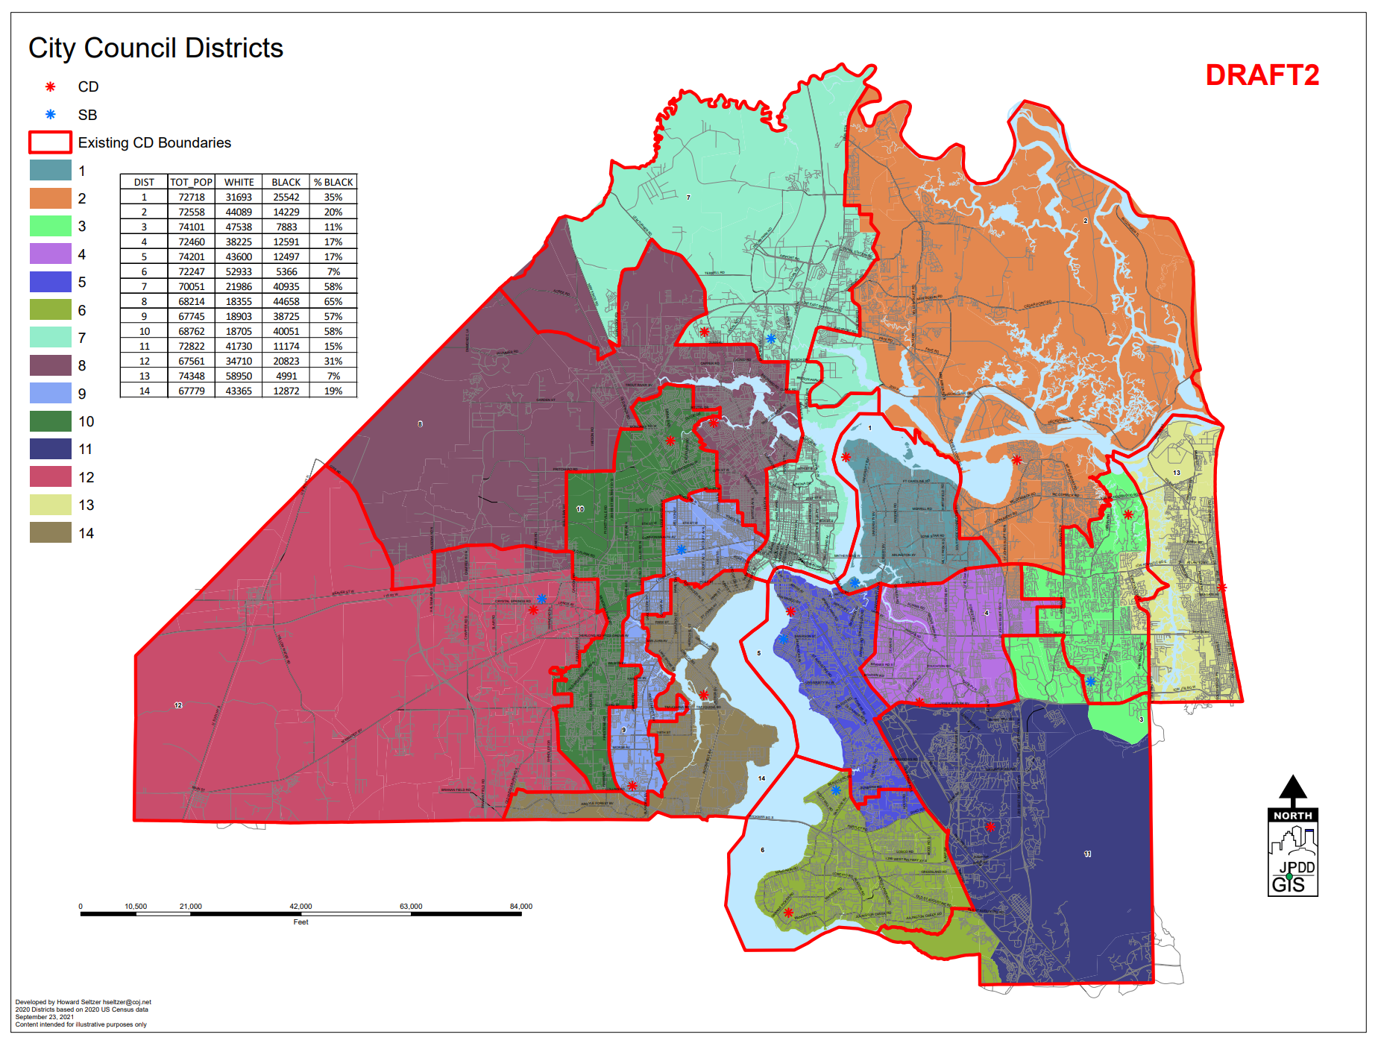
Map 8
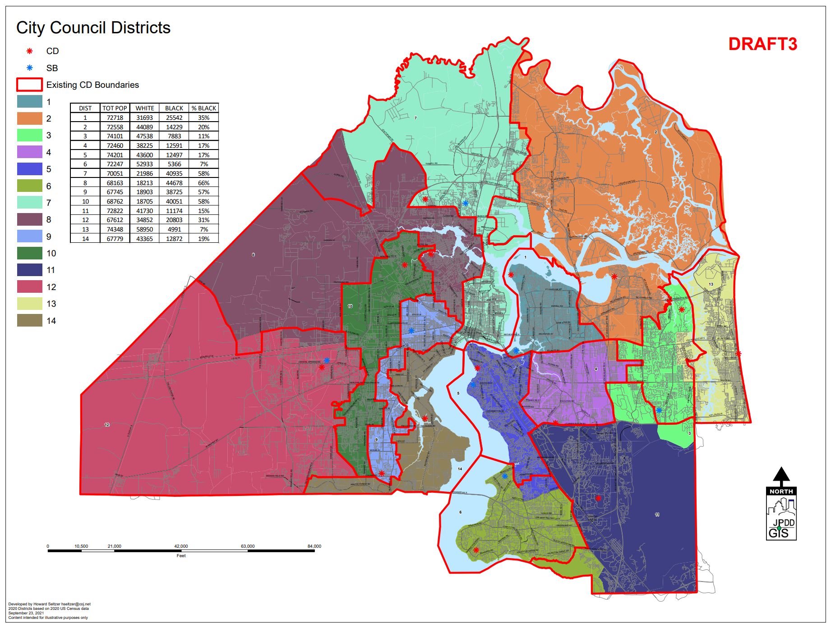
Map 9
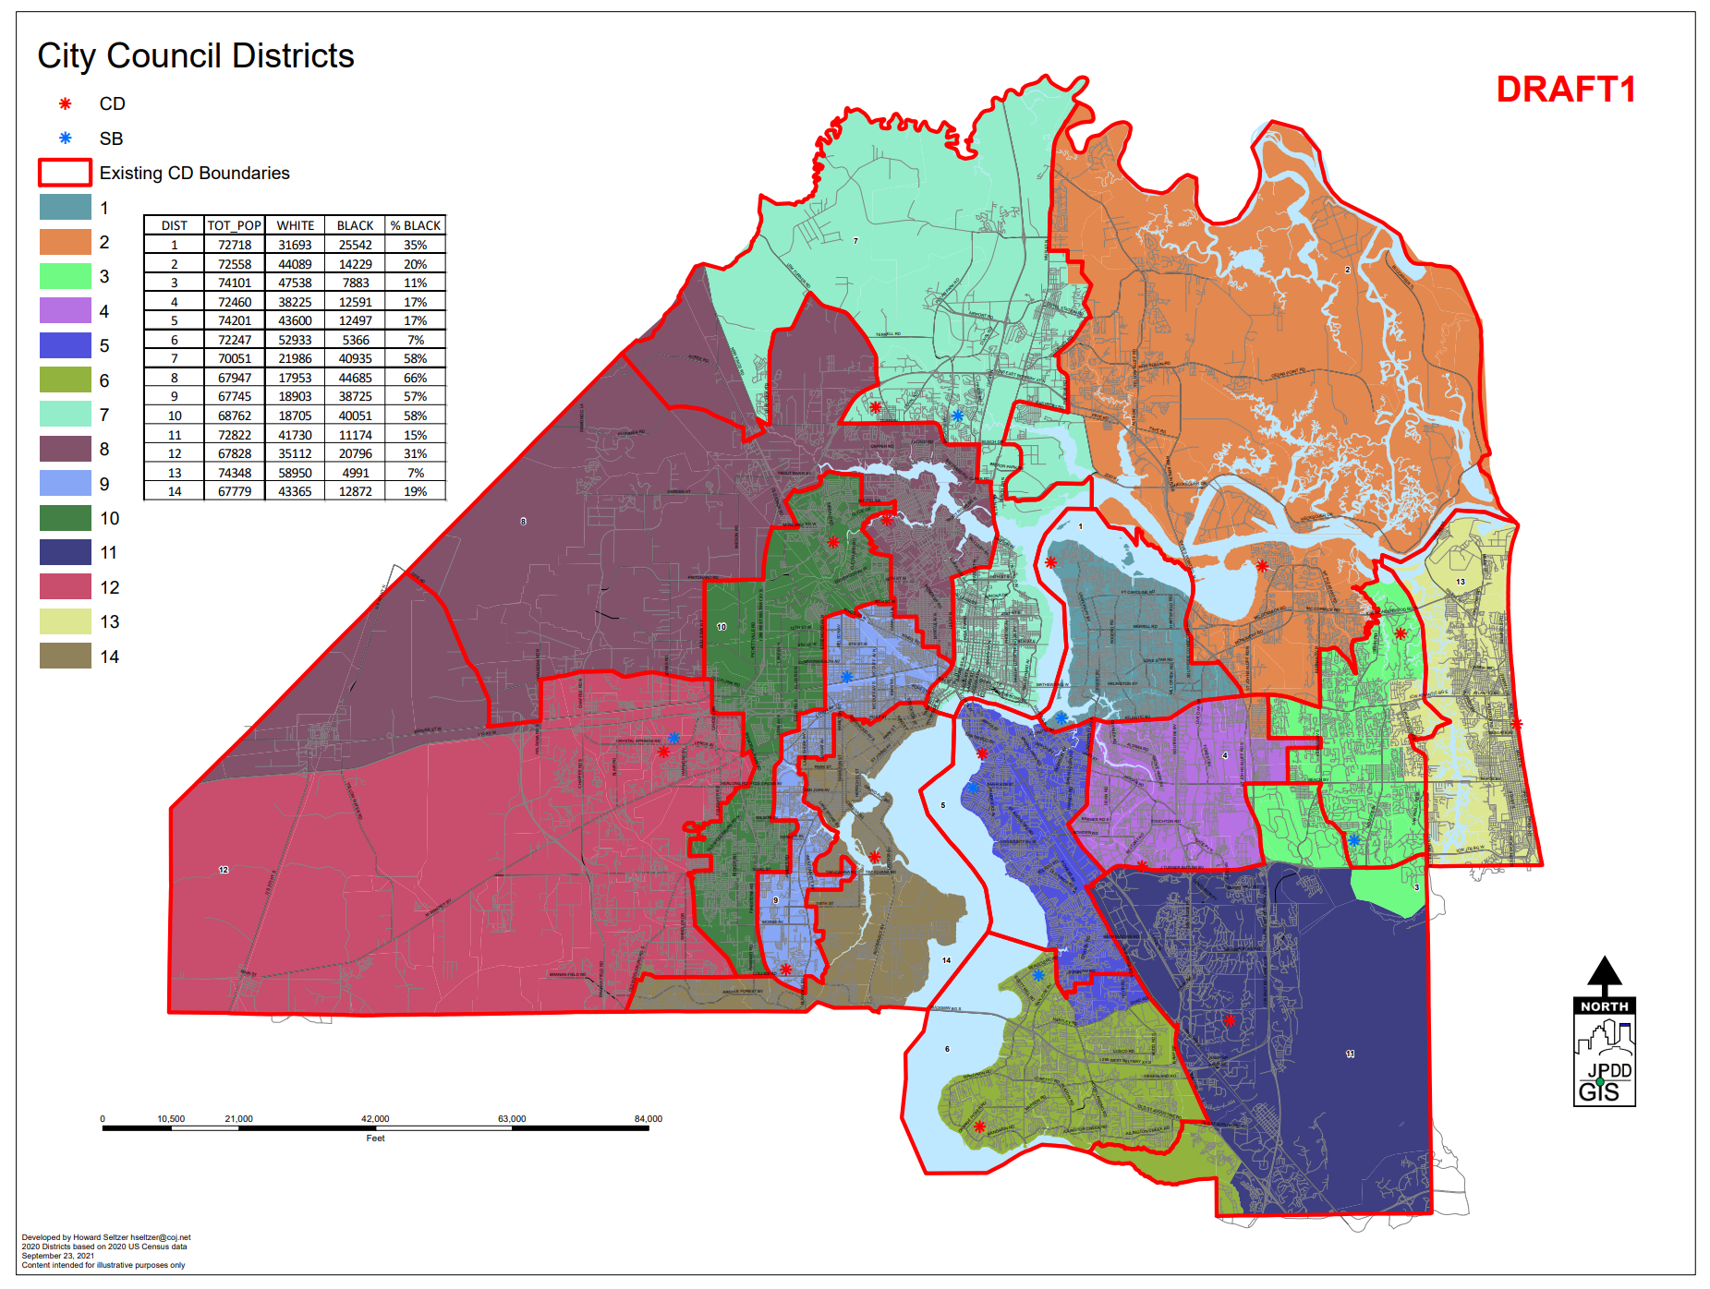
Map 10

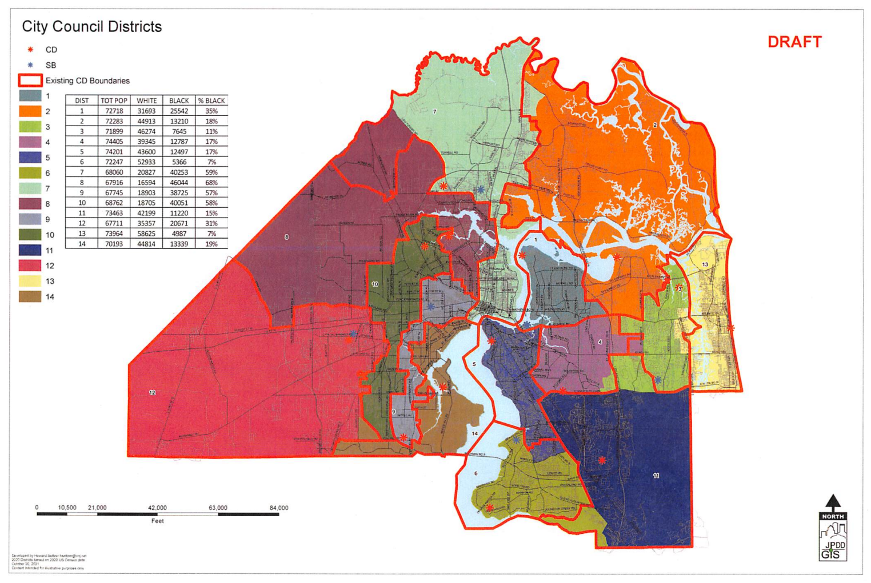
Map 11
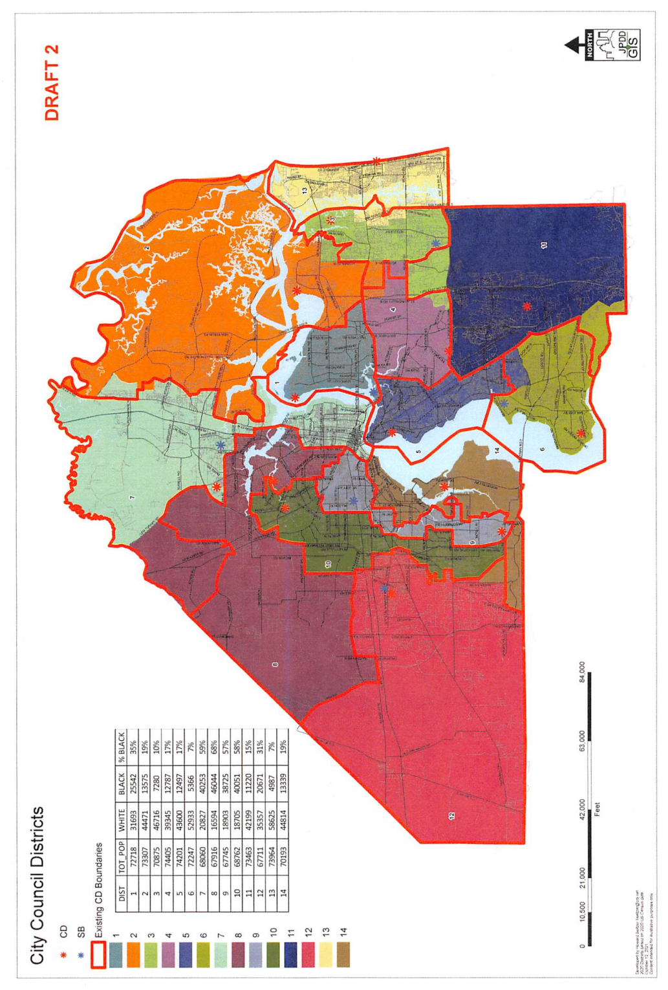
Map 12
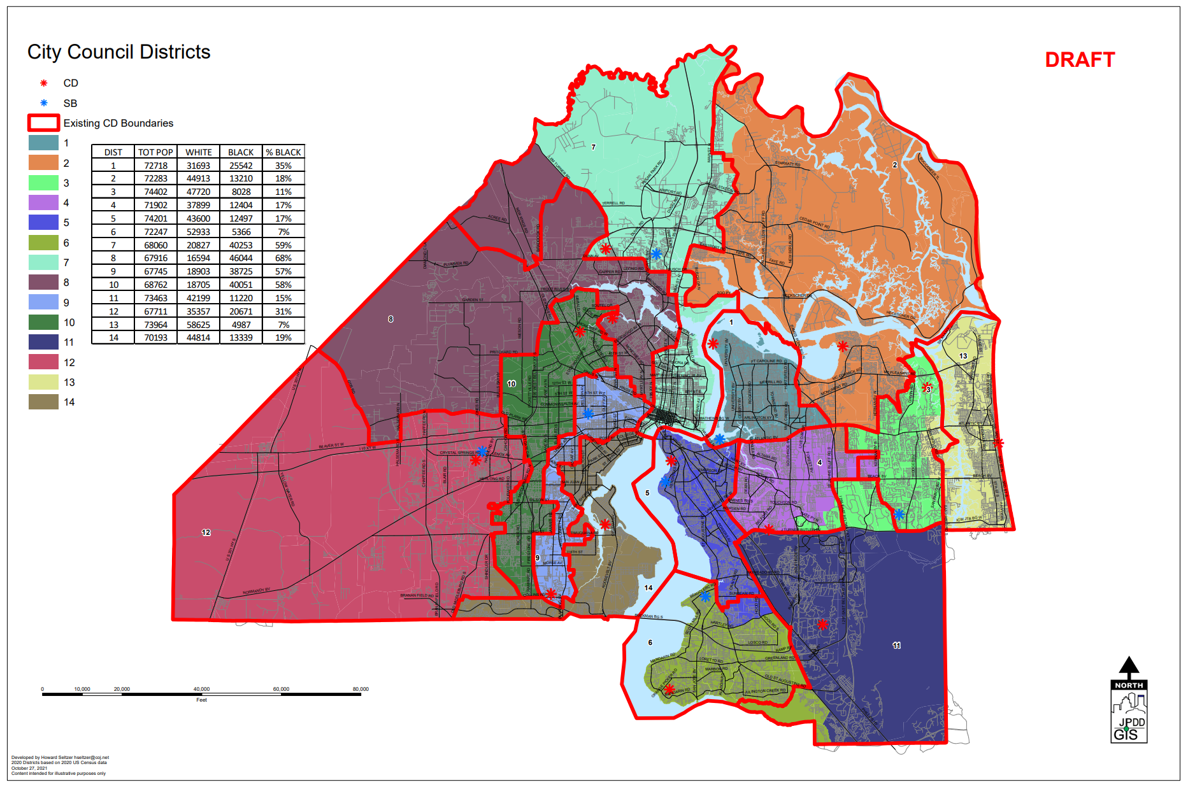
Map 13

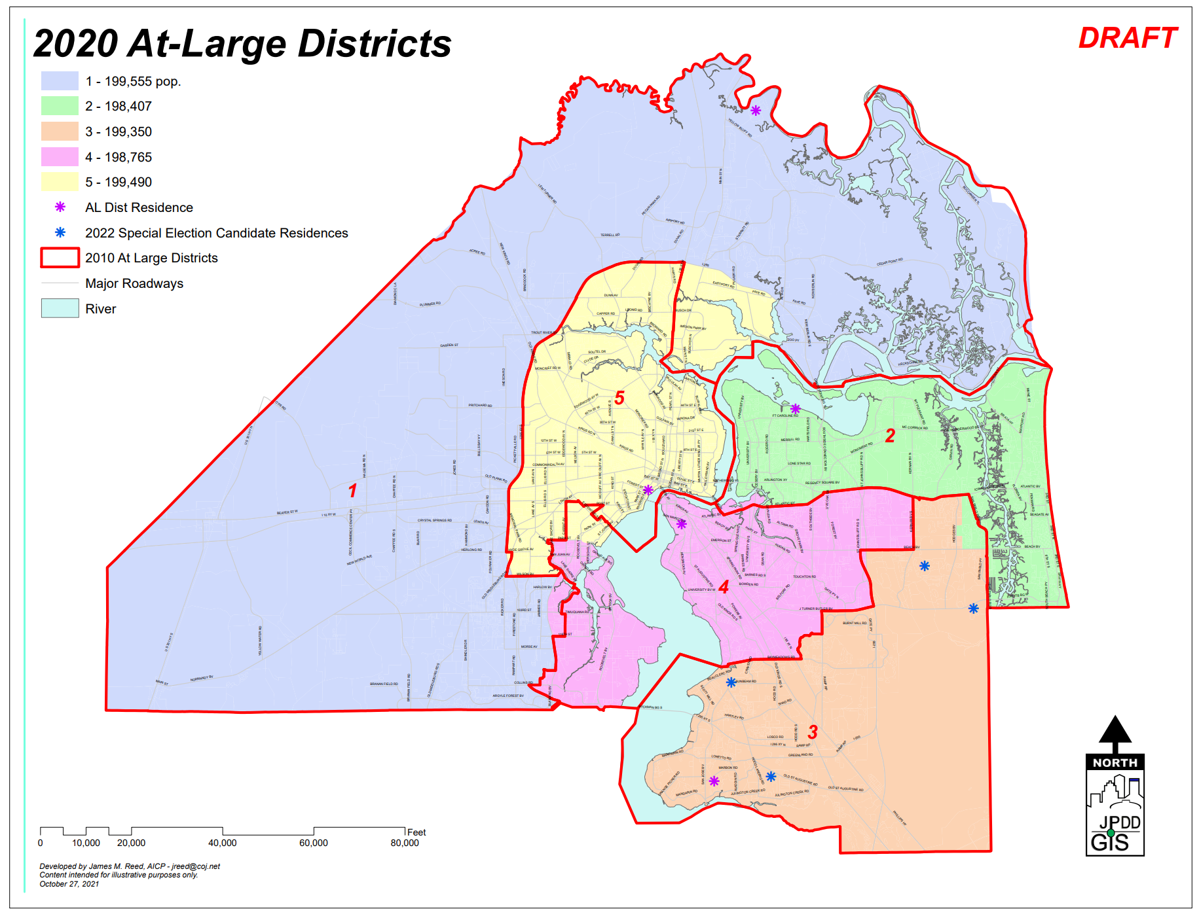
Map 14
Table 1
VOTERS EXISTING CD BOUNDARIES
DIST | DEM | REP | NPA | IND
1 | 20333 | 13719 | 10813 | 534
2 | 16784 | 24067 | 11833 | 726
3 | 14650 | 23825 | 13568 | 718
4 | 16947 | 16852 | 12413 | 675
5 | 16334 | 16602 | 9816 | 521
6 | 14409 | 27335 | 11952 | 717
7 | 28421 | 8164 | 8949 | 526
8 | 29770 | 8350 | 7348 | 348
9 | 25288 | 7157 | 8832 | 453
10 | 27989 | 8590 | 8602 | 446
11 | 20733 | 23394 | 16484 | 1075
12 | 18786 | 19561 | 10244 | 577
13 | 14052 | 23770 | 12126 | 756
14 | 19309 | 18864 | 10995 | 751
TOTAL | 283805 | 240250 | 153975 | 8823
VOTERS NEW CD BOUNDARIES
DIST | DEM | REP | NPA | IND
1 | 20333 | 13719 | 10813 | 534
2 | 16640 | 24202 | 11985 | 717
3 | 14958 | 22290 | 13821 | 745
4 | 15874 | 16318 | 11672 | 630
5 | 17626 | 18499 | 10818 | 586
6 | 14661 | 27343 | 12211 | 734
7 | 28510 | 8510 | 9180 | 546
8 | 30836 | 8727 | 7709 | 372
9 | 25312 | 7192 | 8852 | 454
10 | 28312 | 8697 | 8757 | 455
11 | 17398 | 19451 | 13507 | 895
12 | 17757 | 18701 | 9632 | 543
13 | 15597 | 27019 | 13586 | 837
14 | 19991 | 19582 | 11432 | 775
TOTAL | 283805 | 240250 | 153975 | 8823

Table 2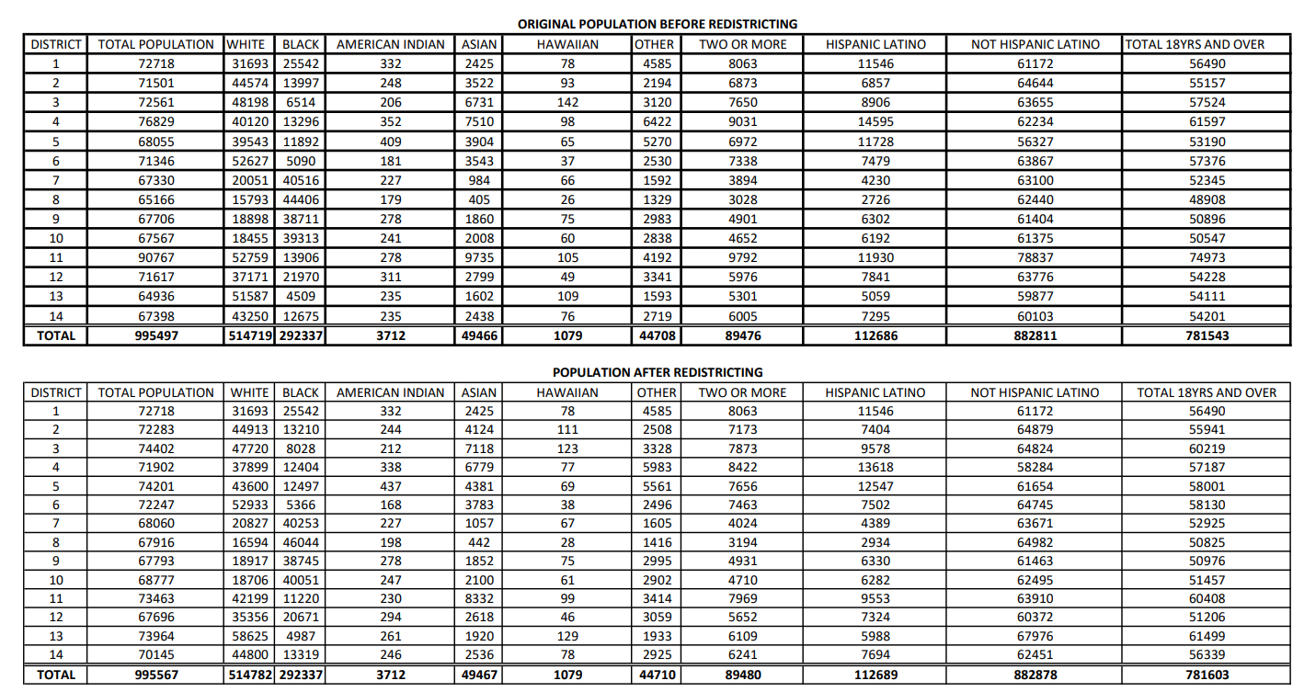
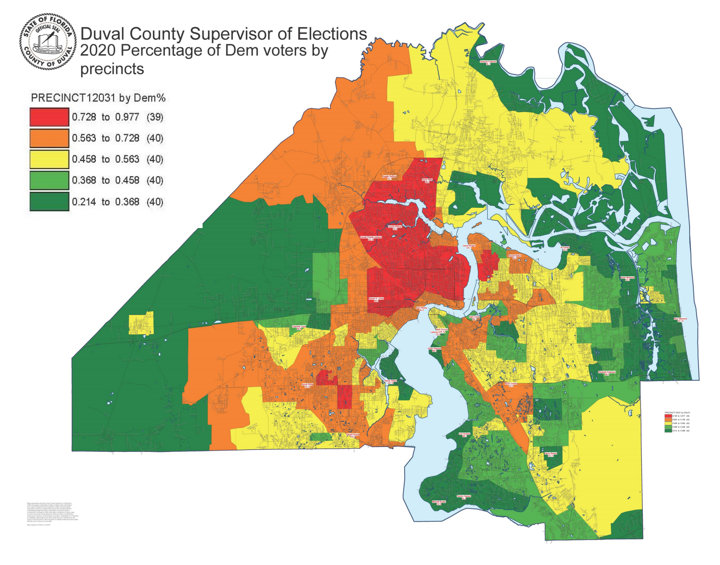
Map 15
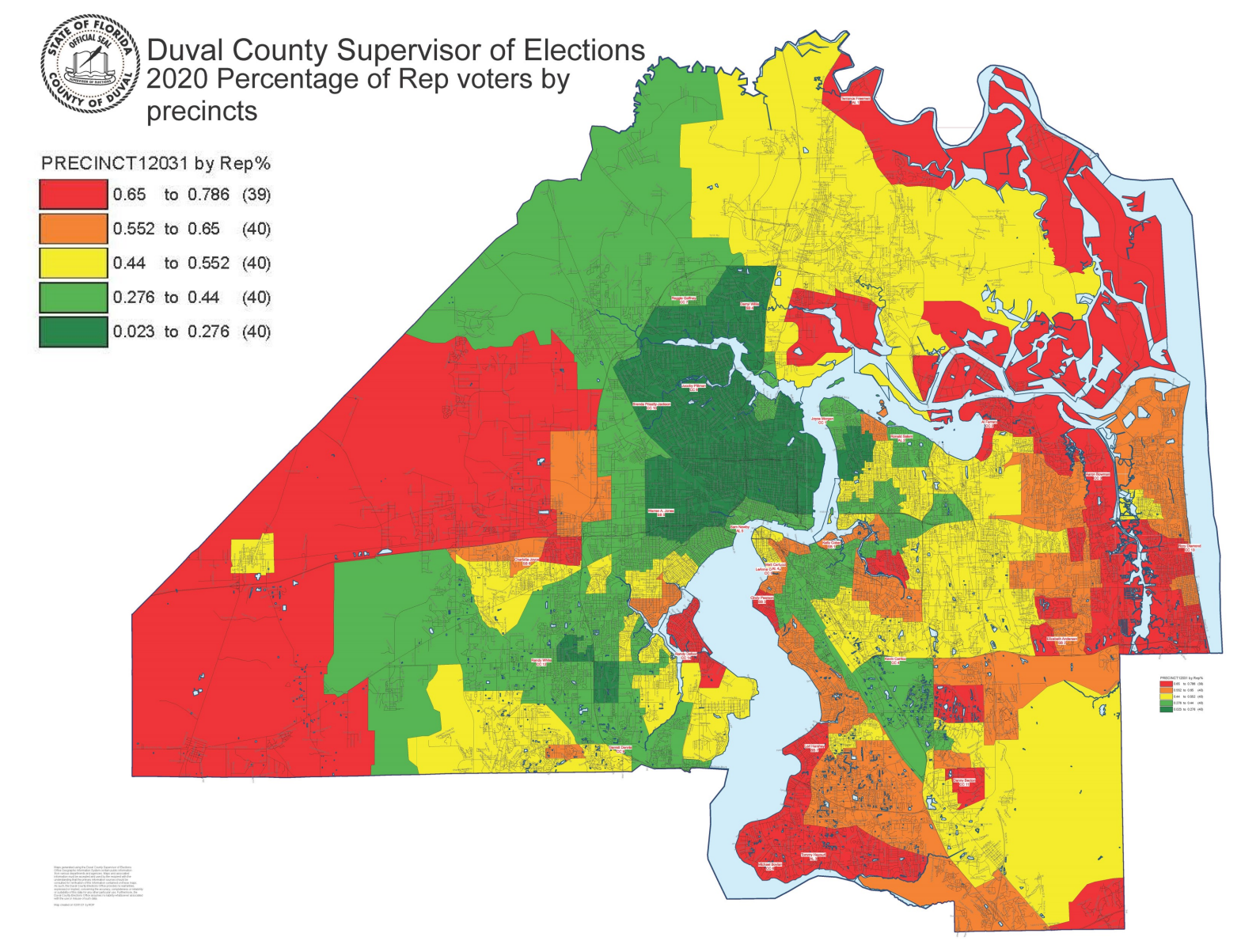
Map 16
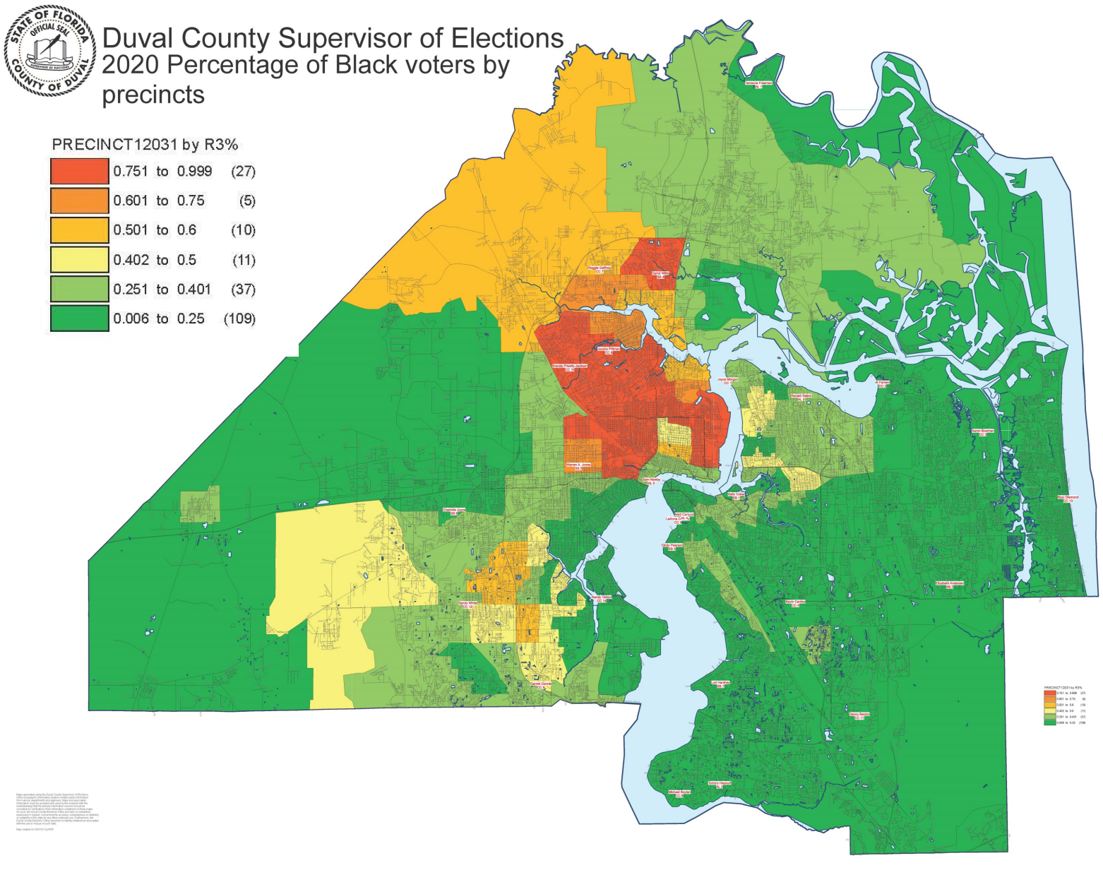
Map 17
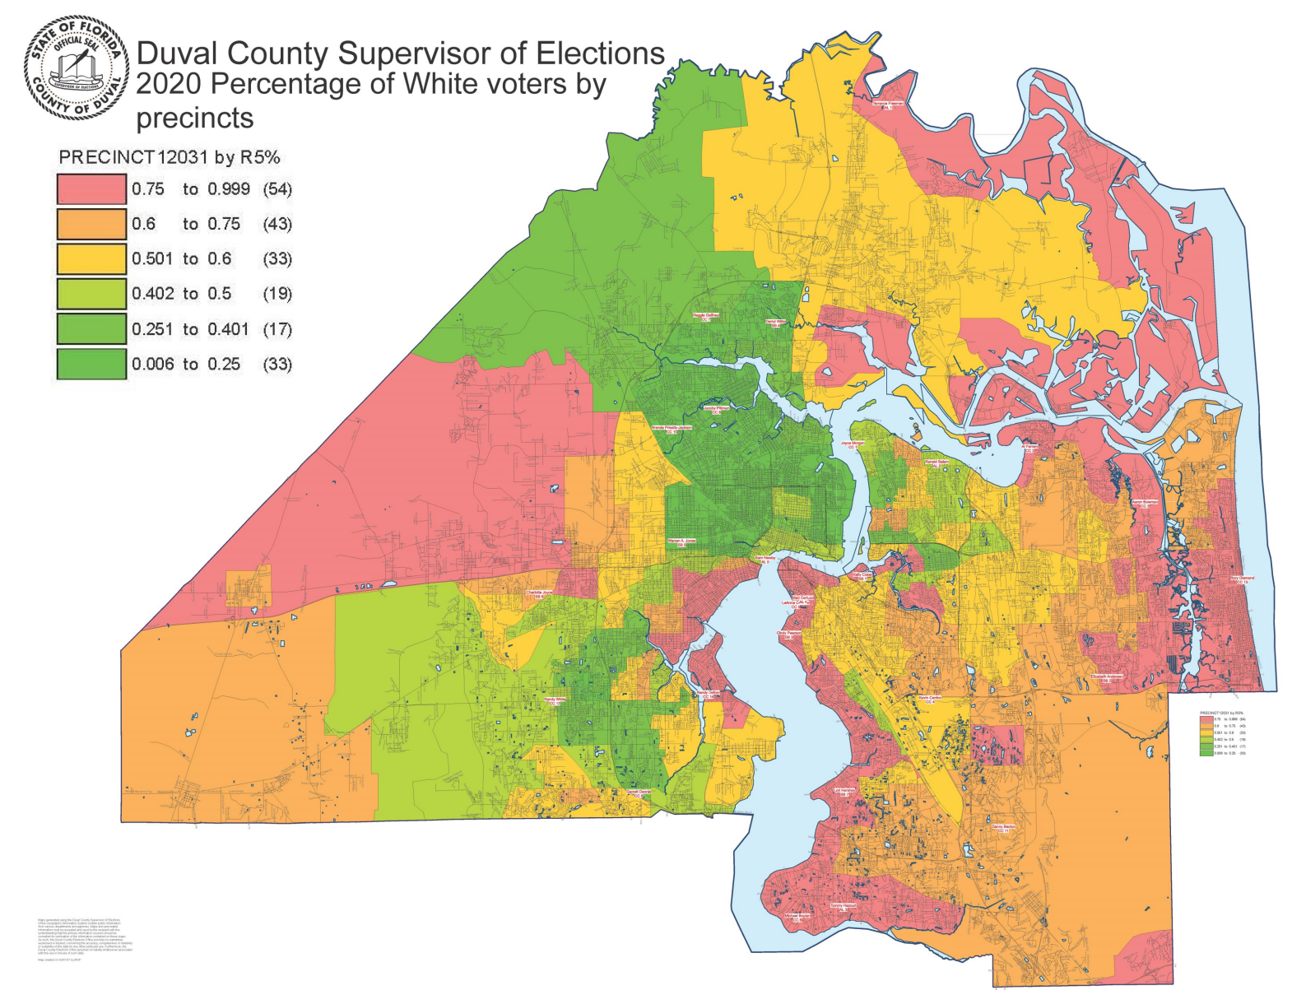
Map 18

